the in-between: an experimental venture into the position of the designer.

author 1
design academy eindhoven

author 2
design academy eindhoven

abstract
Increasing interdisciplinary collaborations between art, design and science, draw attention to the need of elucidating the position of the designer. Such stance is hereby identified as an in-between position, characterised by its exploratory nature, which contributes to the experimental practice of design as a whole. This interstitial position for design, is furthermore identified as an empowering one, which can open up doors to novel opportunities and outcomes, by enabling designers to engage within the processes that construct meaning.

Introduction
In this paper we will try to address the in-between position of the designer as an empowering one, which can open new avenues for research and lead to novel outcomes. Such opportunities might remain closed or distant for those remaining within practices firmly grounded in one discipline or field. Addressing the practice of design as a generative one, we will extract insights from design writers such as Lucy Kimbell and futurist Stuart Candy, but also expand on these views by including filmmaker and writer Trinh T. Minh-Ha's views on liminality.
The reflections contained within this paper derive from personal experiences encountered in recent multidisciplinary projects, such as G-Motiv, which investigates game elements as motivational triggers for behavioural change, within the Creative Industry Scientific Programme (CRISP) in the Netherlands. By presenting examples from such interdisciplinary collaborations, we will explore how working from the in-between, means designers take on different roles within multidisicplinary projects. Such roles vary from intermediaries between the different partners to interventionists in changing situations, as well as knowledge facilitators. Moreover, we hope to illustrate the possibilities and implications such an in-between position of the designer might pose, furthermore contributing to the ongoing discussion on the experimental practice of design.

Embracing uncertainty
Interdisciplinary ventures between designers, artists and scientists inevitably lead to a crossover of work methodologies and ideas. An exchange which often begins with set roles and goals for collaborators. Design, more often than not, will redefine its initial question (Kimbell 2012), changing the nature of the debate. This is a reframing of the initial brief, brought forth by a generative practice, which will extend beyond the pre-defined boundaries of any collaboration.
Designers will play with boundaries, an exploratory practice which is experimental as it entails a questioning of meaning and set definitions. An example can be found in EVASIA, a design fictions proposal currently under development within the G-Motiv project, as part of a Research Associateship at Design Academy Eindhoven. In the context of drug addiction, EVASIA addresses the use of smell as a storytelling tool for addiction patients, by integrating the scent expertise from the Olfactive Design Studio (ODS) from International Flavours and Fragrances (IFF). In this manner, EVASIA expands upon G-Motiv's list of collaborators and knowledge, enhancing the project's focus area by highlighting the relevance of sensory and subjective insights.
This approach situates designers as instigators or generators of situations. Furthermore, it implies a wider scope for design, through an expansion which takes place in more than one direction at a time. These deviations to the official storyline, contribute to a level of ambiguity and uncertainty, which designers must often cope with throughout the project's development. Nevertheless, it is through such side exercises or accidents that meaning is created, essentially informing the design process (see Figures 1 and 2).
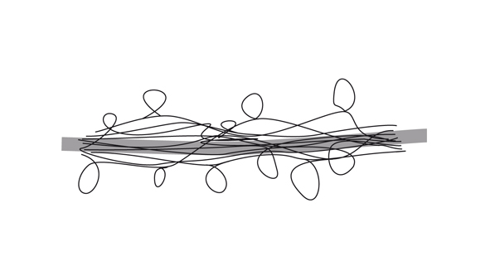
Figure 1: Design process-flow diagram.

Figure 2: Deviations or accidents inform the design process.

the position of the designer
This inquisitive approach is understood through a shift from focus on the process of design, to focus on the position of the designer. Trinh T. Minh-Ha is a filmmaker and theorist whose philosophical writings explore liminal stances, serving hereby as inspiration to validate the in-between position of the designer. Design's explorative nature, requires an understanding of the interdependencies between the different categories at play, which means working within the spaces where these merge and coexist.
This is the space in-between, described by Trinh T. Minh-Ha as "the interval to which established rules of boundaries never quite apply" (T. Minh-Ha 1992). Within the G-Motiv project, it results from the crossovers between the scientific partners (Delft University of Technology, University of Amsterdam, Vrije Universiteit, Erasmus University and the Technical University Eindhoven), the creative partners (Design Academy Eindhoven, Monobanda, IJsfontein, RANJ and Novay) and the service or healthcare providers (Berenschot, Careyn and Brijder). These liminal spaces constantly challenge set structures, furthermore alluding to a shift from seeking a solution to a pre-defined problem, to that of interventions on behalf of the designer.
The in-between position, allows an active influence on the project's knowledge generation processes, validating these by facilitating an exchange of information between the different collaborators. This exchange comes from embracing those "elements that escape the structure", which often lead to "accidents that are created by letting go of things while you are in full control of them" (T. Minh-Ha 1992). Through this approach, design engages in the co-evolution of a multidisciplinary project from different angles, by understanding the different aims and needs of its collaborators. The designer becomes an interventionist, as these exchanges lead to "blueprints and artefacts along the way [which are] designs towards the final design"(Kimbell 2012).
In this manner, the expansive character of design will create and explore new options, rather than limiting itself to pre-existing avenues. An example can be found within EVASIA's Play the Future! workshop, which brought together G-Motiv's creative partners to speculate upon the future of games. The workshop looked beyond the frames of G-Motiv, applying game theorist Leigh Alexander's three postulates on the future of games (games will never end, games won't be perfect, games will be played everywhere) to the three focus areas of G-Motiv: physical stimulation (Alzheimer patients), mental stimulation (addiction patients) and stimulation of pro-social behaviour (workplace environment). Extending beyond the project's immediate goals, the workshop led to outcomes which explored alternative possibilities of collaboration between the creative partners, resulting in three game concepts: tools to catalyse social group behaviour, crowdsourcing emotions through smell, and ringtones for mindsets (see Figure 3).
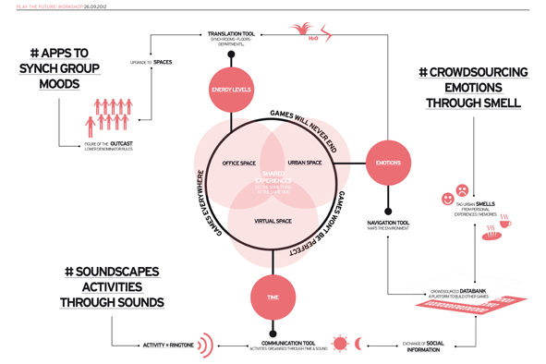
Figure 3: Play the Future! workshop results extended beyond G-Motiv's immediate goals, exploring the future possibilities of games.

meaning, not truth
Working within such liminality means design does not own anything. Designers become intermediaries, which explore and question relationships between science and society, bridging the gap. The parallel stories they conjure from such activities bring forth real desires and anxieties, "creating meaning, not truth" (T. Minh-Ha 1992) as they extend beyond mere sums of facts. This knowledge does not aim to be scientific, as it is not based on objective facts. Rather it derives from a systematic and academic way of producing knowledge. In the case of EVASIA, it stems from a discussion which becomes more precise over time, as the projects, designs and exchanges with G-Motiv's collaborators evolve.
This often requires the need to speak various 'languages' in order to facilitate the necessary exchanges between healthcare providers, patients, scientific, creative and industrial partners. In this respect, design's artefacts serve to materialise "the possibility space" (Candy 2010), since design prototypes themselves also operate as interstices between "the world that is and the world that could be" (Candy 2010), pointing towards alternative processes for the construction of meaning. This implies a merge between fictions and reality, exploring the possibilities of alternative stories. (see Figure 4).
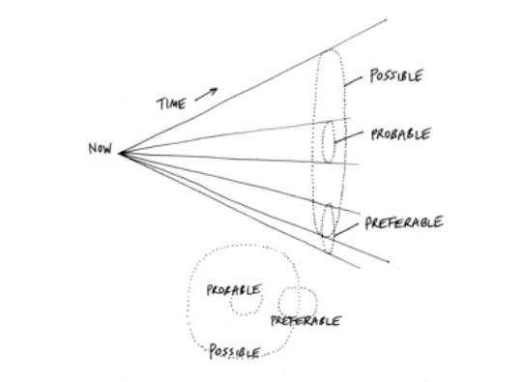
Figure 4: Stuart Candy's diagram of "possible, probable, and preferable futures as subsets of possibility space" (Candy 2010).
Fantasy is a motivating game element, which often addresses the emotional needs of learners, allowing players to experiment with new constructs in low-risk environments (Malone, Lepper 1987). For this reason, an optimum learning environment might be one in which individuals can create their own fantasies. Design fictions can provide conversational platforms (Candy 2010), through which parallel stories can be told, addressing human needs and desires. Acting as testimonies of contemporary culture, these stories can provide contexts to investigate further play’s frames and its paradoxes for therapy (Bateson 1955/1972).

EVASIA plays with fictions, to explore such parallel stories in the context of drug addiction. It merges subjective experiences with the objective, data-driven definitions of individuals, building upon personal memories and experiences as a platform for healthcare providers. In this manner, it hopes to explicit ways for an active and playful engagement within the politics of health, by bringing forth new meanings and moving beyond the conception of people as numbers.

parallel stories
To explore alternative ways of constructing, a series of workshops will take place with adolescents in the drug-rehabilitation clinic and detox centre Mistral in Den Haag, counting with the support from the ODS / IFF and the G-Motiv partner and Dutch healthcare provider, Brijder. Smell, will be used as a tool for communication and self-expression, to devise alternative ways of storytelling by exploring its link with memories and emotions.
Smell is one of the natural triggers that activate the brain’s reward system (Wise 2002), affecting the release of dopamine, a pleasure producing chemical and important neurotransmitter. Drugs hijack the reward circuit of the brain, causing floods of dopamine, which encourages us to repeat actions through feelings of pleasure. EVASIA will investigate positive and negative past experiences through the abstract narratives of olfactory memory. For this purpose, a series of smell webs (see Figure 5) will be created through exposure to a selection of pleasant / unpleasant smells. These will serve as a platform for storytelling and sharing, through which personal emotions and memories will be mapped. The resulting stories will be used to empower Mistral's patients to consider the smells of their future. Likewise, the smell of rehabilitation for the clinic will be explored and created by the patients, extrapolating their personal stories to a collective well-being.
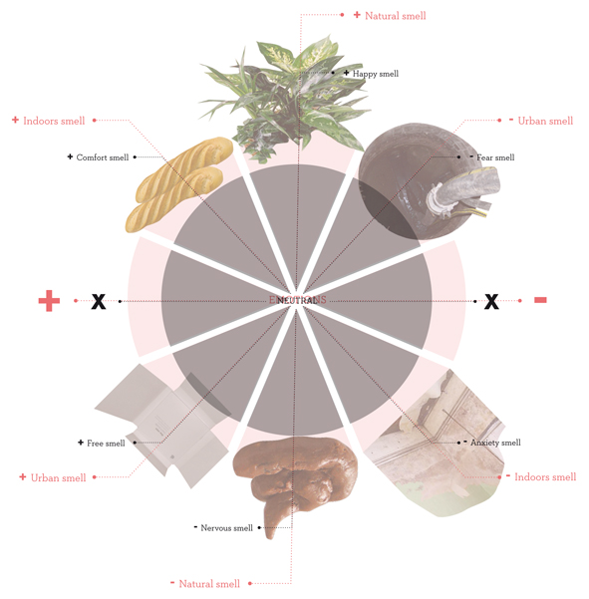
Figure 5: Smell-web diagrams for alternative storytelling.

to speak nearby
Exploring alternative ways of expression, creates platforms design can engage with, from a human-scale. This approach involves a constant play between different narratives, engaging with fact and fiction. In this manner "the narratives shift back and forth between being informational, reflective or analytical, and being emotional, trivial, absurd or anecdotal" (T. Minh-Ha 1992). In the context of EVASIA, this suggests a direct engagement with the reality of the patients, where design provides the necessary tools and voice for the construction of their own definitions and meanings.
This is intrinsic to design's concern with the "human or micro-scale" (Kimbell 2012). Such co-creation devices and processes differ from mere data gathering exercises. Instead, they generate awareness, by drawing attention to the politics of health and its social manipulations, whilst actively contributing to the construction of personal identity.
Taking an in-between position is therefore also an act of resistance, as design does not intend to "speak about", but to "speak nearby" (T. Minh-Ha 1992). This is how designers confront "truth", questioning pre-set notions and processes. This is often threatened by the risk of instrumentalisation faced by design, within multidisciplinary collaborations, such as G-Motiv. Seen as a mere one-to-one translator, communicator or visualiser, such risk denotes the use of design as a tool to validate set meanings. A notion that corresponds to a "management perspective" which conceives design as "another phase" (Kimbell 2012) within the project. This approach, detaches design from its explorative ability whilst limiting its creativity.
The in-between position of the designer, ensures an experimental and critical practice for design, as it refuses to reduce its role "to that of a mere device to authenticate the message advanced" (T. Minh-Ha 1992). Instead, design will provoke new ideas, awareness and reflections, by pointing to the processes that construct new meanings. Furthermore, by speaking nearby, design is no longer subject to the regulations of those well-defined boundaries, therefore gaining the necessary freedom to explore the possibility space (See Figure 6).
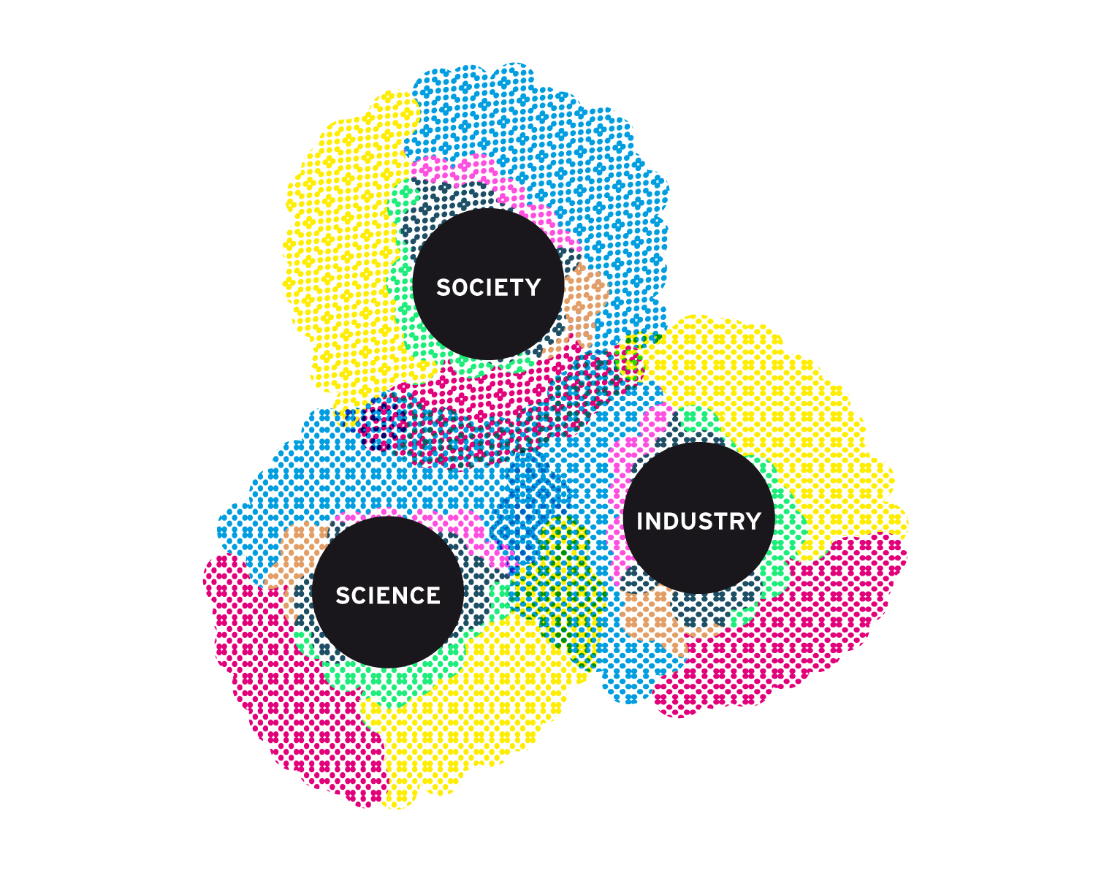
Figure 6: To "speak nearby" means designers operate within the possibility space (coloured areas), from an in-between position.

final considerationS
In this paper we looked to integrate insights from outside experts to design research, such as filmmaker and theorist Trinh T. Minh-Ha and futurist Stuart Candy. Combining their 'liminal' views with those offered by known voices within the design profession such as Lucy Kimbell, we hoped to further expand on the notion of the in-between, likewise alluding to ways in which the design practice can be informed from such external perspectives.
The notion that design oscillates between such interstitial stances, could only be contemplated through the scope where such peripheral visions merge and coexist. In the course of an ongoing academic debate on what design is, this is in no means intended as another definition for design. Instead, it stands as an ode to its experimental nature, as such resistance to categorisation is what perhaps allows it to continuously expand its frontiers.

COnclusions
Design's experimental nature is intrinsic to its expansive character. This often leads to deviations or side exercises that account for the ambiguity and openness of its practice. Such an approach, requires a shift from focus on the process of design to focus on the position of the designer: namely an in-between position, which operates within an interstitial, or possibility space. Interventions within such liminalities, enable designers to explore processes at the micro, or human scale whilst embracing the parallel stories that result from such encounters. In this manner, design does not speak about, but nearby, as it provokes and highlights the processess that construct new meanings.

references
Kimbell, L. 2012. 'Design Commission Inquiry into Redesigning Public Services. Evidence from Lucy Kimbell'. Design leads us where exactly?: Design and design thinking in public services, weblog post, 22 November, accessed 7 December 2012, <http://designleadership.blogspot.co.uk/2012/11/design-and-design-thinking-in-public.html?utm_medium=referral&utm_source=pulsenews>.
T. Minh-Ha, T. 1992. 'Framer framed', London: Routledge, pp.161-180, pp.181-190.
Candy, S. 2010, ‘The Futures of Everyday Life: Politics and the Design of Experiential Scenarios', Creative Commons, pp.22-59.
Bateson, G. 1955/1972, 'A Theory of Play and Fantasy in his Steps to an ecology of mind', New York:Balantine Books, pp. 177-193.
Malone, T. W., & Lepper, M. R. 1987, 'Making learning fun: A taxonomy of intrinsic motivations for learning. In R. E. Snow & M. J. Farr (Eds.), Aptitude, learning, and instruction, III: Conative and affective process analysis', Hillsdale, NJ: Lawrence Erlbaum Associates, pp. 223-253.
Wise, RA. 'Brain Reward Circuitry:Insights from Unsensed Incentives'. Neuron. 2002; 36:229-340.

